**My Dream House**

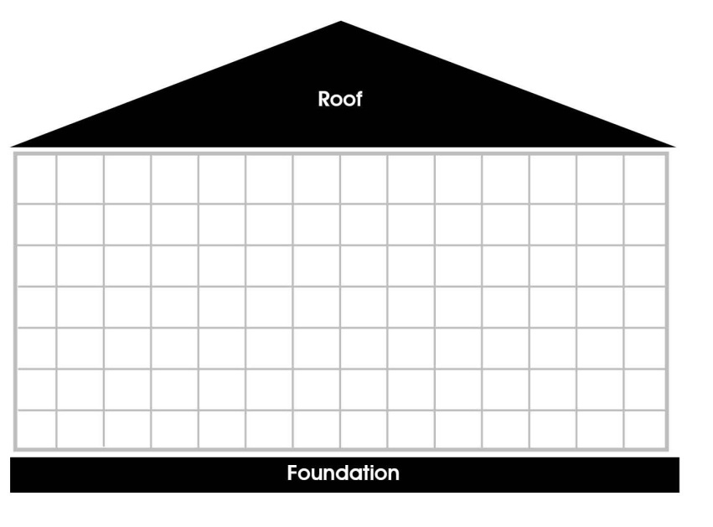

**My Current House**

